# Deployment of index.html from different repo’s on httpd server
-Anushka Vijay Gaikwad

- installed httpd and started it on JM
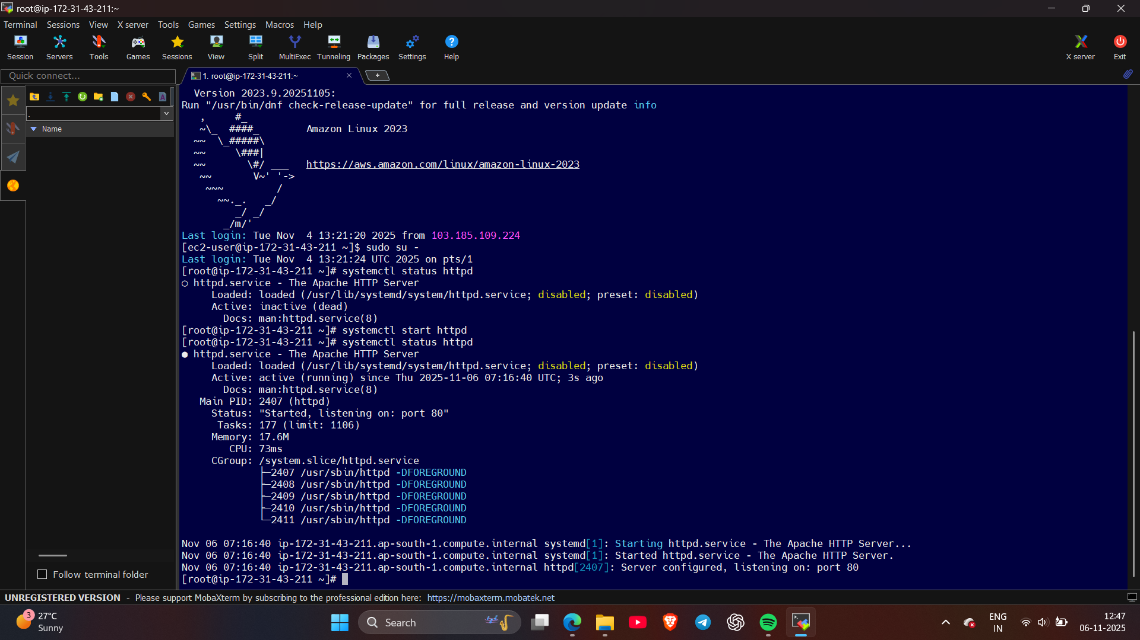
- Created 3 repositories and created index.html file in each
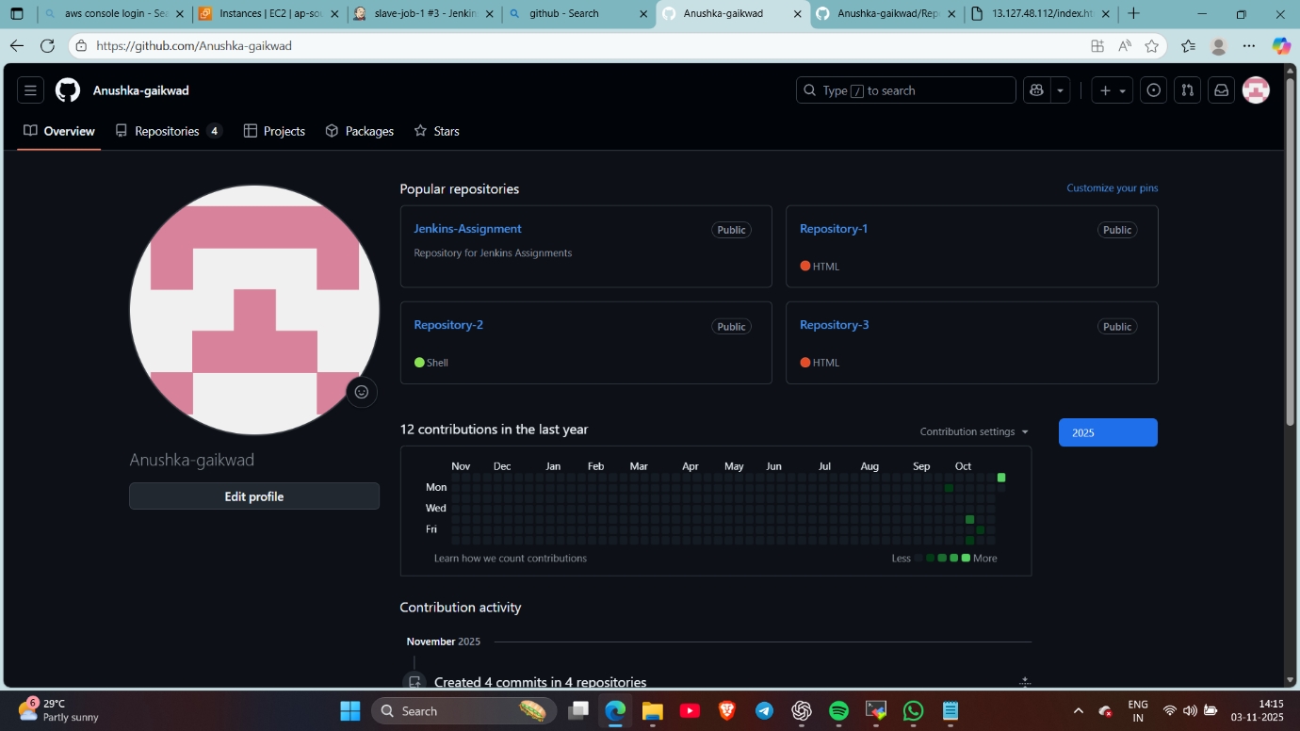

- Create a pipeline job 1 to clone repo and to copy its file on httpd server
pipeline {

agent {

label {
label "built-in"

}
}

stages {

stage ("clone repository") {

steps {
echo "cloning repository..."
git branch: '2025Q1' , url: 'https://github.com/Anushka-gaikwad/Repository-1.git'

}

}

stage ("deploy file") {

steps {

script{

sh '''
rm -rf /var/www/html/index.html
cp index.html /var/www/html/index.html
chmod -R 777 index.html /var/www/html

'''
}
}

}
}
}

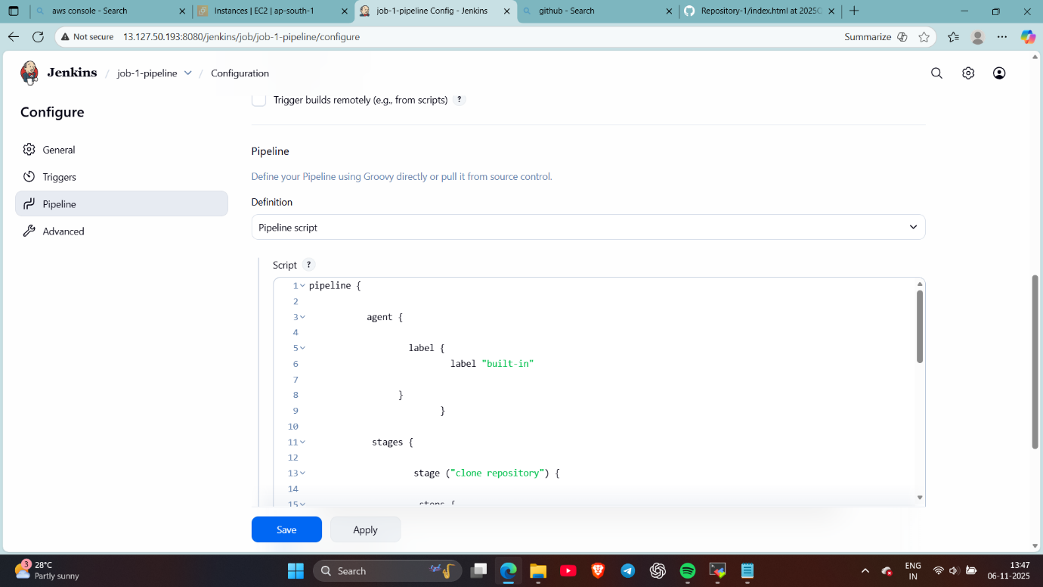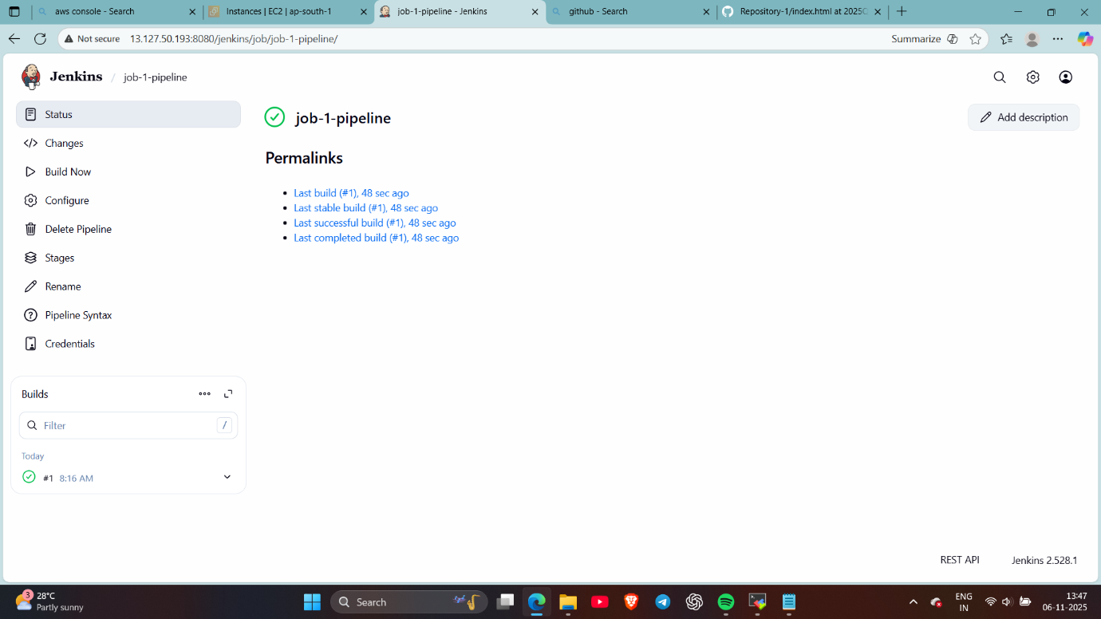
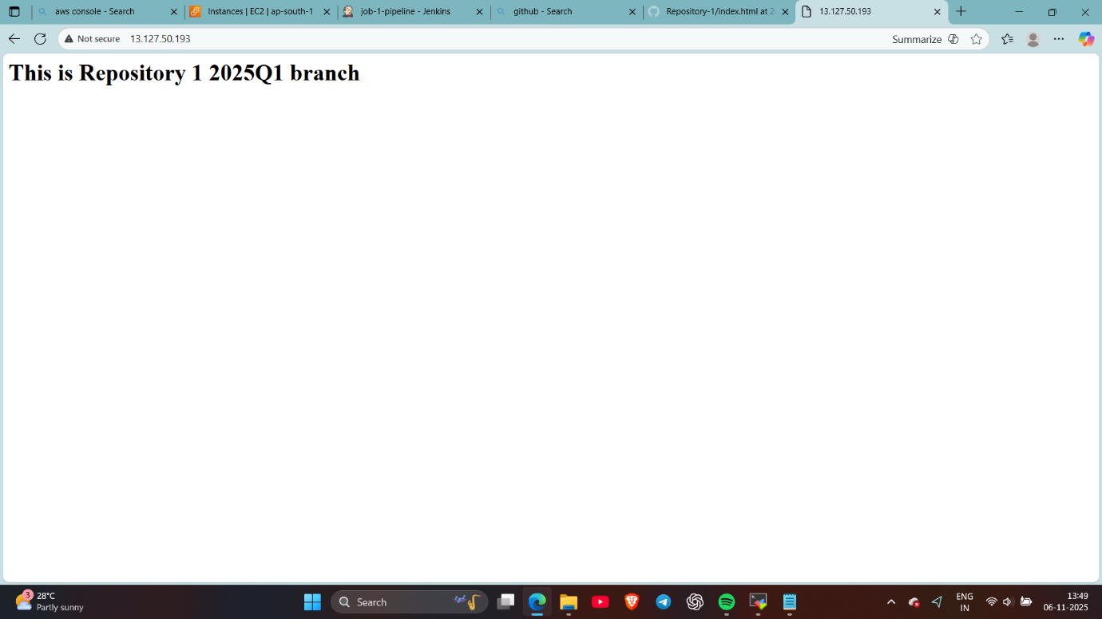
- Like this created job 2 so repo 1’s index file will be deleted and repo 2’s file will deploy on server
pipeline {

agent {

label {
label "built-in"

}
}

stages {

stage ("clone repository") {

steps {
echo "cloning repository..."
git branch: '2025Q2' , url: 'https://github.com/Anushka-gaikwad/Repository-2.git'

}

}

stage ("deploy file") {

steps {

script{

sh '''
rm -rf /var/www/html/index.html
cp index.html /var/www/html/index.html
chmod -R 777 index.html /var/www/html

'''
}
}

}
}
}

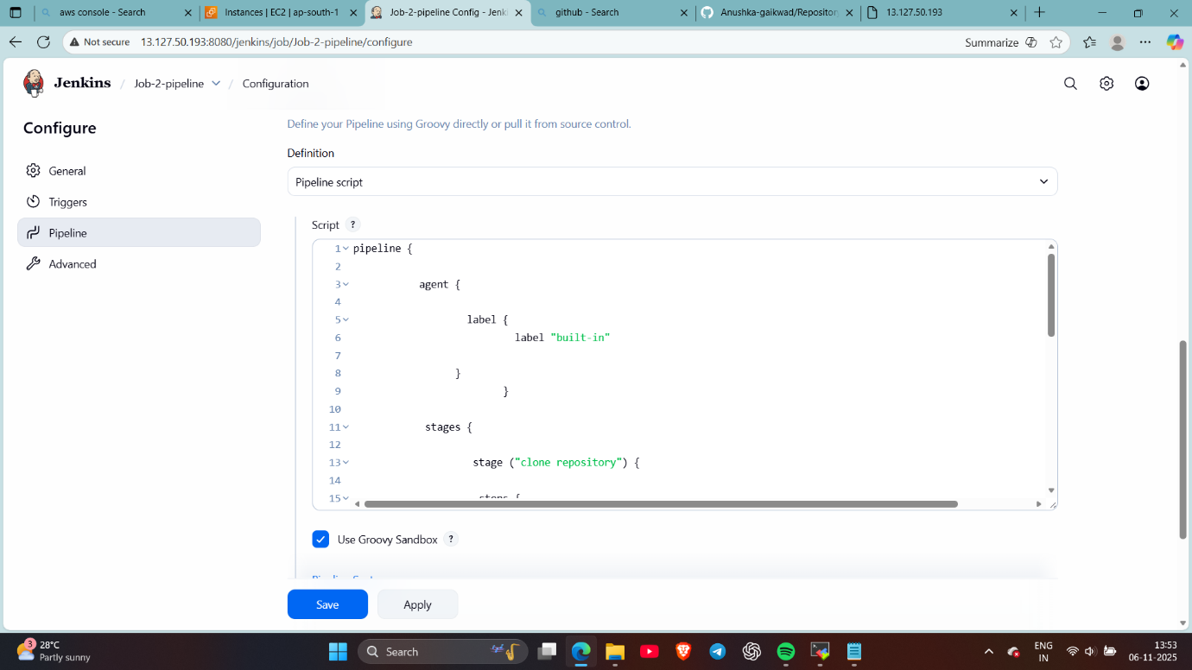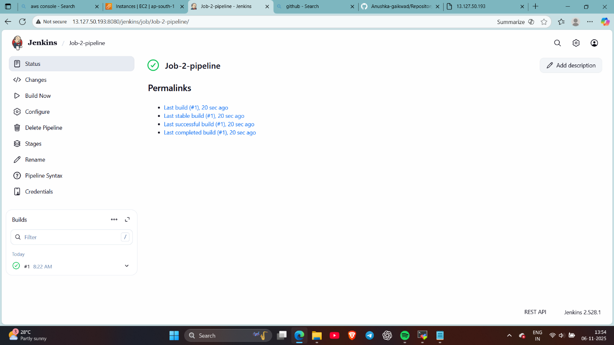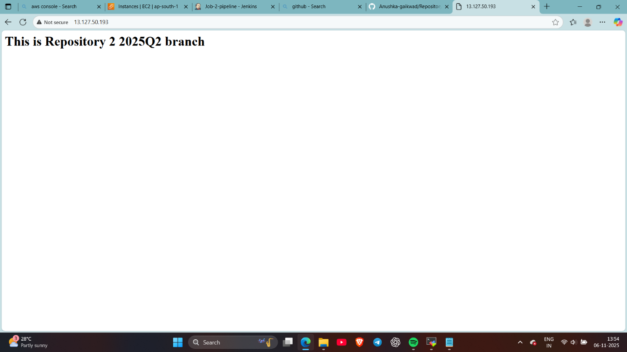
- Created job 3
pipeline {

agent {

label {
label "built-in"

}
}

stages {

stage ("clone repository") {

steps {
echo "cloning repository..."
git branch: '2025Q3' , url: 'https://github.com/Anushka-gaikwad/Repository-3.git'

}

}

stage ("deploy file") {

steps {

script{

sh '''
rm -rf /var/www/html/index.html
cp index.html /var/www/html/index.html
chmod -R 777 index.html /var/www/html

'''
}
}

}
}
}

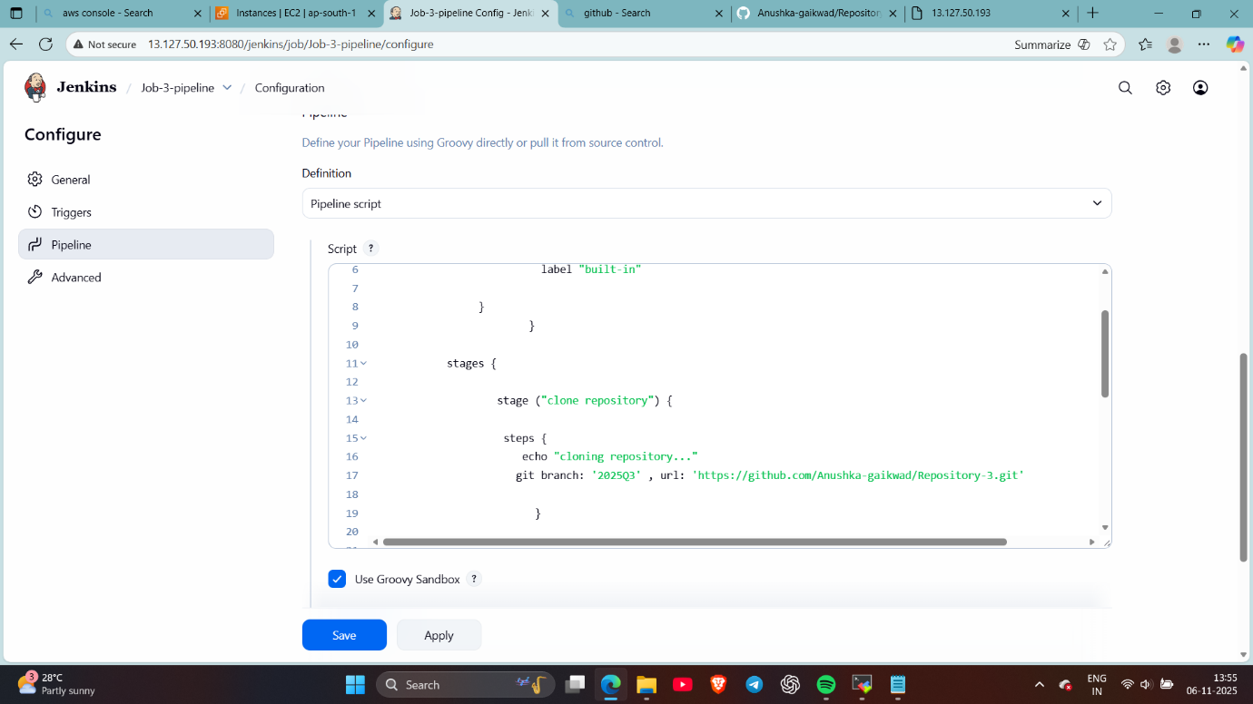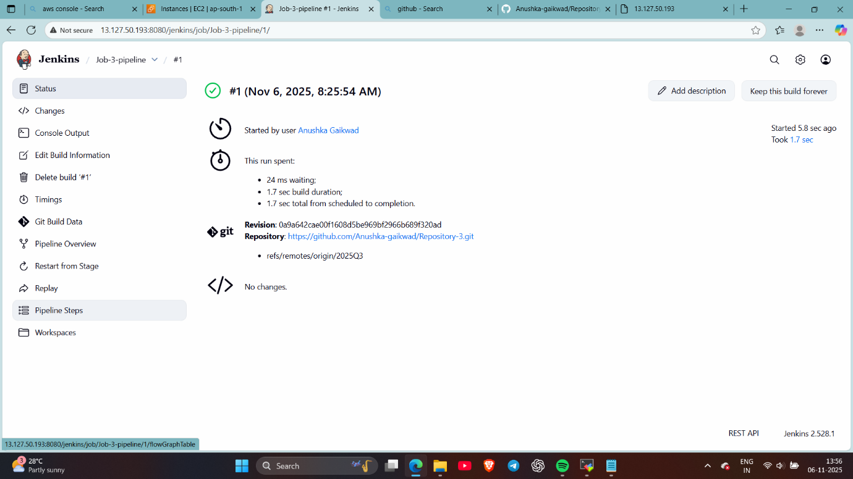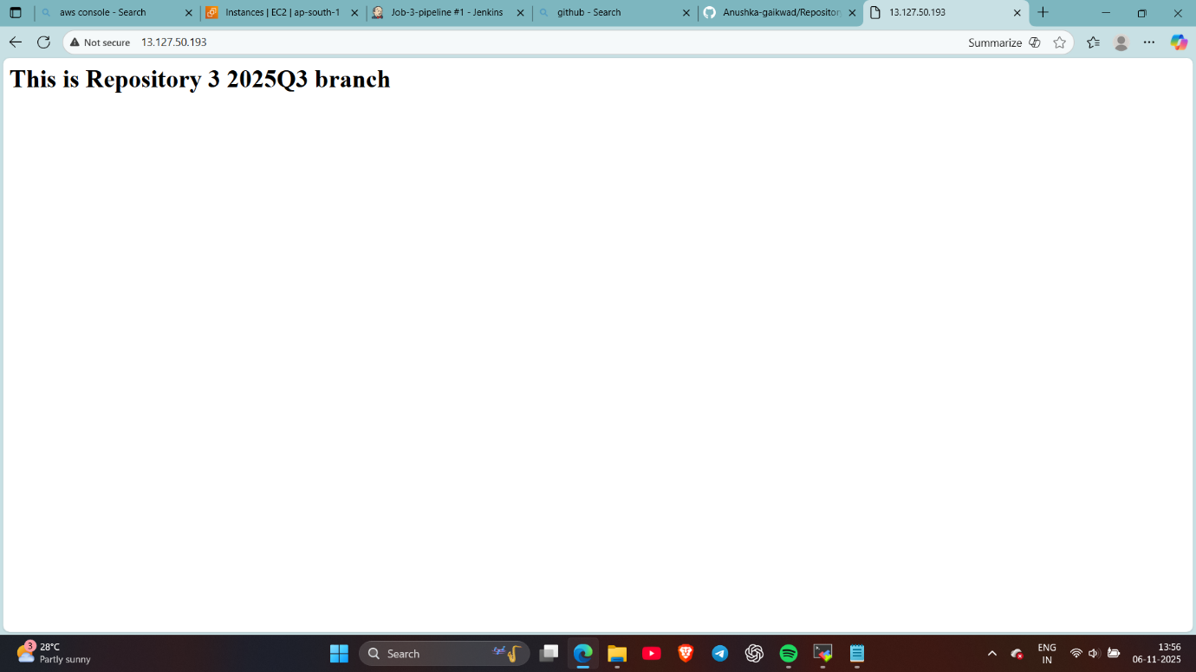checked via browser
Done ….

